# June 1, 2021

# Program Manager, Water Efficiency & Billing #26773

|  |  |
| --- | --- |
| **DEPARTMENT:** Environmental Services Department  **BRANCH:** Infrastructure Asset Management Branch | Salary: $107,874 to $126,846 annually |
| **LOCATION:** 17250 Yonge Street, Newmarket  **STATUS:** Temporary Full-Time, Approx. 30 Months  **SCHEDULED WEEKLY HOURS:** 35  **SCHEDULED SHIFTS:** 0830 – 1630  **START DATE: Immediate** | This is a Replacement  Non-Union position |

**POSITION PURPOSE**

Reporting to the Manager, System Sustainability Management is responsible for leading and coordinating water and wastewater billing by providing advice, including technical and statistical analysis; liaising with local and regional partner municipalities and agencies regarding water and wastewater billing to maintain the Region’s interests and assure a significant source of revenue. Collaboratively share data; initiating and coordinating continuous quality improvement initiatives to improve data collection, data analysis and the water and wastewater billing process. Managing the development, implementation, and continuous improvement of the Department’s water conservation and efficiency programs, to support the Region’s and local municipal water conservation programming, including non-revenue water, infrastructure master planning and other regulatory related activities; managing the development and documentation of sustainable programs and procedures including the long term water and conservation strategy to support Provincial, Regional, Departmental and local municipal objectives.

**MAJOR RESPONSIBILITIES**

* Leads and coordinates wholesale water and wastewater billing program, including approval of payment to applicable partner municipalities; verification of data and submits to Department finance unit for invoicing; liaises, negotiates and resolves disputes.
* Leads the departmental billing process review initiative to continuously improve customer bills and process to be customer friendly.
* Provides water and wastewater data analysis, insight and recommendations to departmental senior management.
* Develops, oversees and reports on the water conservation program including alignment to Vision 2051, corporate strategic plan and department objectives.
* Facilitates the Water Conservation Advisory Steering Committee and Partnership meetings with the external stakeholders.
* Provides leadership to guide implementation of the Long Term Water Conservation Strategy including strategy updates and annual reporting on progress to achieve long term reduction targets.
* Coordinates with internal staff, local municipalities, Conservation Authorities, non-government organizations and consultants to develop communications strategies, print and web based material, to promote sustainable use of the Region’s drinking water supplies for residents and businesses in coordination with internal stakeholders.
* Leads the data management and governance of billing data including the investigation of water and wastewater data management systems to identify issues; documents all investigations and recommends remedial measures to Management.
* Supervises staff, including recruitment, selection, hiring, scheduling, assigning and monitoring work, determining training and development needs, coaching and mentoring, setting annual performance goals, conducting performance appraisals and determining/recommending disciplinary action up to and including dismissal in accordance with collective agreements, Regional policies and practices.
* Represents the Department at meetings with public and other agencies for preparation of the Long Term Water Conservation Strategy and Water/Wastewater Master Plan.
* Assumes functions of the Manager in that person’s absence, as directed.

**QUALIFICATIONS**

* Successful completion of a University Degree in Civil/Environmental Engineering, Environmental Sciences, Applied Science or related field, or approved equivalent combination of education and experience.
* Minimum three (3) years of relevant experience related to monitoring flows in municipal water and wastewater systems; public and partnership programs to address water conservation measures; including experience with non-revenue water, knowledge of water and wastewater budgeting and financing principles to complete detailed technical and financial analysis; demonstrated minimum of (two) 2 years of direct supervisory experience.
* Demonstrated project management skills to lead a project or work group, organize numerous tasks, set priorities and meet deadlines.
* Experience and understanding of business development in terms of practices, information, data, business processes, information systems and organization, including analyzing, modelling and providing insight and recommendations on large technical data sets.
* Strong communication skills and experience in making presentations to staff and senior management.
* Leadership competencies including operating strategically, leveraging diversity and differences, customer focused, ensuring accountability, managing complex problems, financial management, employing interactive and effective communication, fostering collaborative relationships, cultivating engagement to drive vision and purpose, managing and developing talent, establishing and maintaining trust, displaying self-awareness, and demonstrating resiliency.
* Knowledge and demonstrated ability in corporate core competencies including customer focus, communication, collaboration and personal ownership.

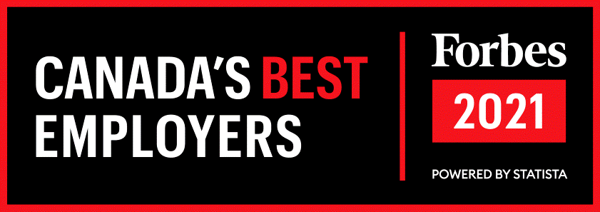 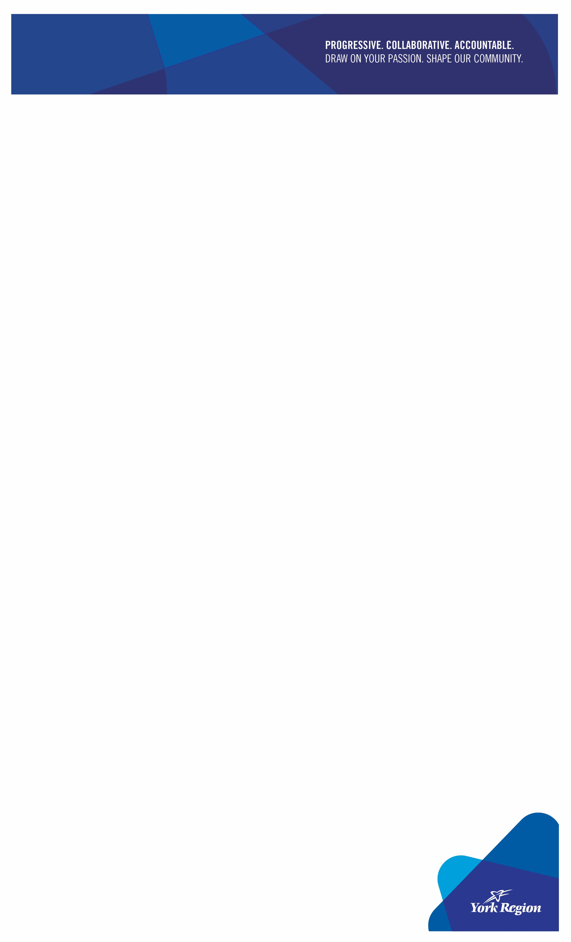

*York Region is an equal opportunity employer committed to an inclusive, barrier-free recruitment and selection process. At the Region, we respect, encourage and celebrate our diversity. If contacted for an employment opportunity, please advise if you require accommodation.*

Please apply online by June 14, 2021 **at 4:30 p.m.** As an alternative, you can apply via e-mail to careers@york.ca

All job vacancies are recorded on a 24-Hour Career Line and may be accessed by calling 1-877-464-9675 ext. 75508.

We thank all candidates for their interest; however, only those selected for an interview will be contacted via email.